From Roadmap to Reality: Realising Blue Economy Workforce Potential in the Niger Delta

February 16, 2026
By Jonathan Turner, NLAI Co-Founder and Director
As I stood on stage at the Four Points by Sheraton in Ikot Ekpene during the maiden Niger Delta Blue Economy Investment Summit (9–11 February 2026), the energy in the room was in striking contrast to a typical policy dialogue. It was clear that this was not a group who had convened to discuss theoretical possibilities; we were all there to make a transition from ambition to practical mobilisation. My closing reflection on the Summit was that Nigeria possesses ocean wealth that goes far beyond its oil: vast fisheries, rivers, beaches, delta landscapes and deep coastal waters suitable for world-class ports. But as I spoke with governors, naval leaders, and international investors, one question underpinned many of our conversations: “How do we turn this vast potential into millions of sustainable ‘blue jobs’ for local people?”.
This is not merely a regional aspiration, but a demographic imperative that rightly permeates all areas of policy. Africa is already the youngest continent in the world, with a median age of just 18.8 years in 2023, compared to a global median of 30.5. Every year, 11 million young Africans seek work, but just 3 million wage jobs are created. With Africa’s working-age population expected to double by 2050, the scale and speed of this demographic shift mean that rapid livelihood creation is a necessity.
Consequently, the challenge and, therefore, the amazing opportunity is to ensure that a healthy number of these new jobs can be found within a sustainable Blue Economy that not only provides livelihoods but, furthermore, balances production with protection. In Nigeria alone, the Blue Economy holds the potential to generate over $100 billion annually. Some of these gains can be achieved by driving efficiencies into existing industries. For example, the annual loses of 420,000 tonnes of fishdue to post-harvest waste is a clear signpost for the need to invest in parts of the fisheries value chain. Each tonne lost is a job lost; each dollar of imported fish (grossing over one billion dollars annually) is a painful missed opportunity for local livelihood empowerment. Other industrial sectors, such as coastal tourism, are in their infancy.
As I was pondering these stats, I was reminded of the publication of the High Level Panel for a Sustainable Ocean Economy’s landmark Blue Paper, The Future of the Workforce in a Sustainable Ocean Economy, which came out last year. This substantial report (co-authored by NLA International’s Leila Ben Hassen), provides the robust evidence base we need to move from hypotheses to bankable approaches. It highlights a staggering projection: properly supported, a sustainable ocean economy could create 51 million additional jobs globally by 2050, bringing the total workforce to 184 million. For Africa, where the Blue Economy already supports an estimated 49 million jobs, the mission is not simply to participate in this global shift, but to shape it, by deliberately building the skills, institutions and enterprises required to compete and expand. The Niger Delta has a role to play in meeting this fundamental challenge.
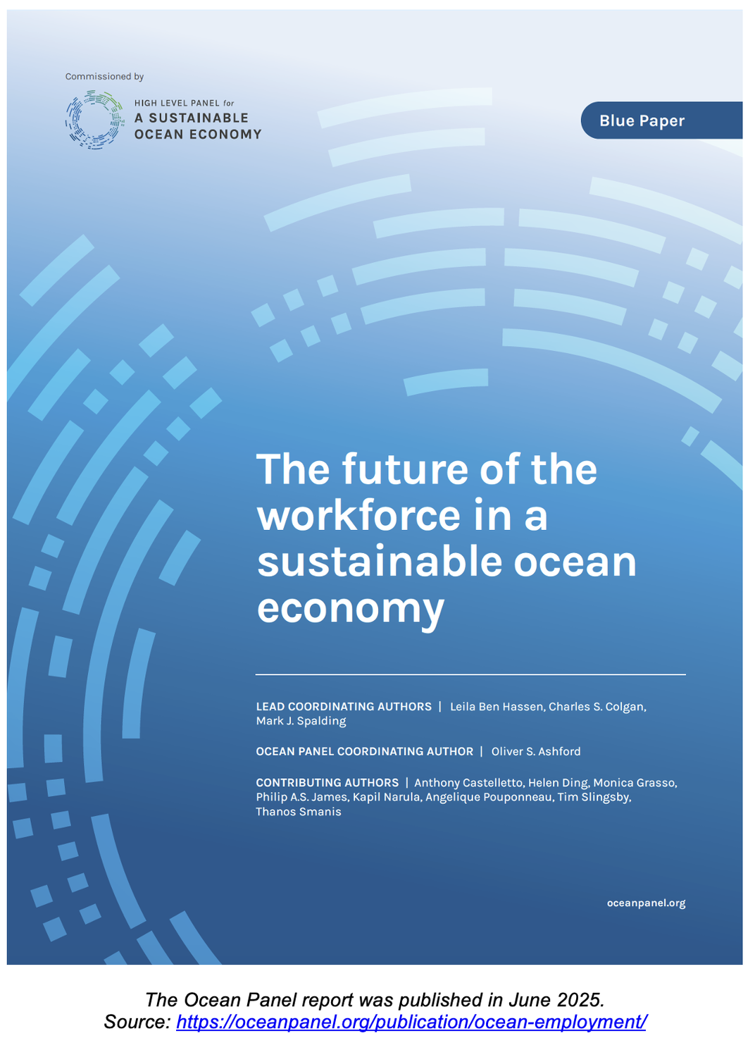
If we are to avoid the all too prevalent trap of reports becoming ‘shelfware’ we must look at where practice is already ahead of policy. Thankfully, there is much tangible progress to consider, under some pretty consistent themed headings.
Building the Skills Pipeline
The ‘skills gap’ is perhaps the most significant boundary to blue growth, particularly in developing nations. Almost as the Summit closed, the Technical University of Mombasa (TUM) announced a 10-year, €5.5 million programme focusing on the Blue Economy and health. Funded by VLIR-UOS, this is not just meant to be a research grant, but a targeted capacity pipeline that includes PhD scholarships and innovation hubs designed to translate academic research into community adoption. This institutional strengthening is mirrored by the African Development Bank-backed Sh2.1bn Blue Economy research and training facility at TUM, which focuses on port management, maritime logistics, and climate-resilient infrastructure.
Creating the jobs is one thing, but as new employment opportunities open up so must corresponding educational and training pathways. In October 2025, the Las Palmas de Gran Canaria city council approved an Interreg MAC grant to implement “Blue Professions Weeks”. This initiative brings vocational pathways directly to young people, making maritime careers visible and accessible. The European Commission has also scheduled a Youth Policy Dialogue for March 2026 to explicitly discuss blue career opportunities with young leaders, in a laudable attempt to ensure that governance stays connected to the future workforce.
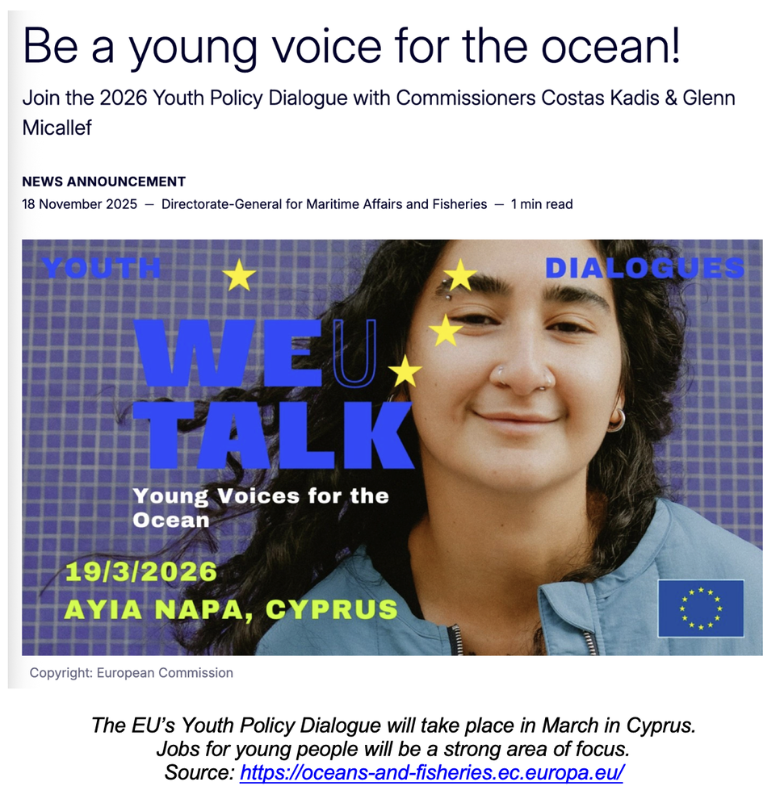
Industrialising the Value Chain
Job creation in the Blue Economy hinges on professionalising traditional sectors. In Zanzibar, February 2026 saw the launch of a $117 million fisheries and aquaculture project under the TASFAM initiative. Funded by the World Bank, it provides modern equipment and loans to seaweed farmers and fishers, with a processing factory designed to support the livelihoods of 160,000 people, 80% of whom are women.
In Morocco, the National Aquaculture Development Agency (ANDA) presented a 2026 Action Plan last December featuring 35 strategic projects. They have already demonstrated success: in 2025, Morocco saw 1.76 billion dirhams (approx. €160m) in investment, creating over 2,300 direct jobs. Their national dialogue on seaweed farming, held in September 2025, projected that scaling to 300,000 tons annually could create 36,000 jobs and $450 million in revenues.
Infrastructure as a Catalyst
Infrastructure development to create spaces wherein new jobs can thrive is a prerequisite for unlocking the blue workforce. Back in Kenya, President William Ruto announced a Sh25 billion investment in ‘blue infrastructure’ in June 2025, focusing on fish landing sites and cold-chain markets. These sites are designed to reduce the 30% post-harvest loss that plagues small-scale fishers, effectively turning waste into wealth for youth and women, while making the sector more attractive to a new generation. This supplements his Sh1.2 billion plan to acquire 15-20 deep-sea fishing vessels to drive competitiveness in this critical sector.
In Nigeria, the Federal Government approved contracts last year for the modernisation of the Western Ports (Lagos Ports Complex, Apapa, and Tin Can Island), under a project forecasted to generate over 20,000 jobs. Similarly, the planned Agge Deep Seaport in Bayelsa is being positioned as a major maritime gateway that will open new frontiers in logistics, shipbuilding and marine services for the Niger Delta, all of which will boost local employment opportunities.
Embedding Indigenous Knowledge
The Ocean Panel Blue Paper rightly emphasises that a ‘just transition’ – shifting to a low-carbon, sustainable economy in a way that protects workers and communities – must include traditionally marginalised groups. In the Pacific Islands, the Blue Pacific Youth Initiative is training local youth in marine conservation and sustainable fisheries to ensure jobs remain in the islands rather than contributing to ‘brain drain’. In the Solomon Islands (as referenced in the Ocean Panel report), communities are also being trained in mangrove restoration and carbon credit projects, turning traditional stewardship into income-generating blue jobs.
This approach is replicated in Canada, where strong engagement around the national Blue Economy Strategy has led to the integration of Indigenous Guardian programmes. These programmes use Indigenous knowledge alongside modern science to manage marine protected areas, providing high-value employment that respects cultural heritage.
Scaling Blue Entrepreneurship
Self-employment and a growing startup community will be another important cornerstone of the jobs challenge. The EU-backed BlueInvest Africa 2026 programme recently opened a "call for pitchers", providing African startups with a direct route to investors. With a track record of supporting over 80 startups from 700+ applications, this mechanism demonstrates how institutional support can scale small- and medium-sized enterprises (SMEs) into significant employers.
Other approaches to supporting such enterprise-led logic include the Sabah state government in Malaysia (an emerging Blue Economy leader) which has established a Blue Economy Council, signalling dedicated financing pathways to attract eco-investors. The emphasis is not only on environmental positioning, but also on creating the governance and capital conditions that allow firms to form, expand and employ.
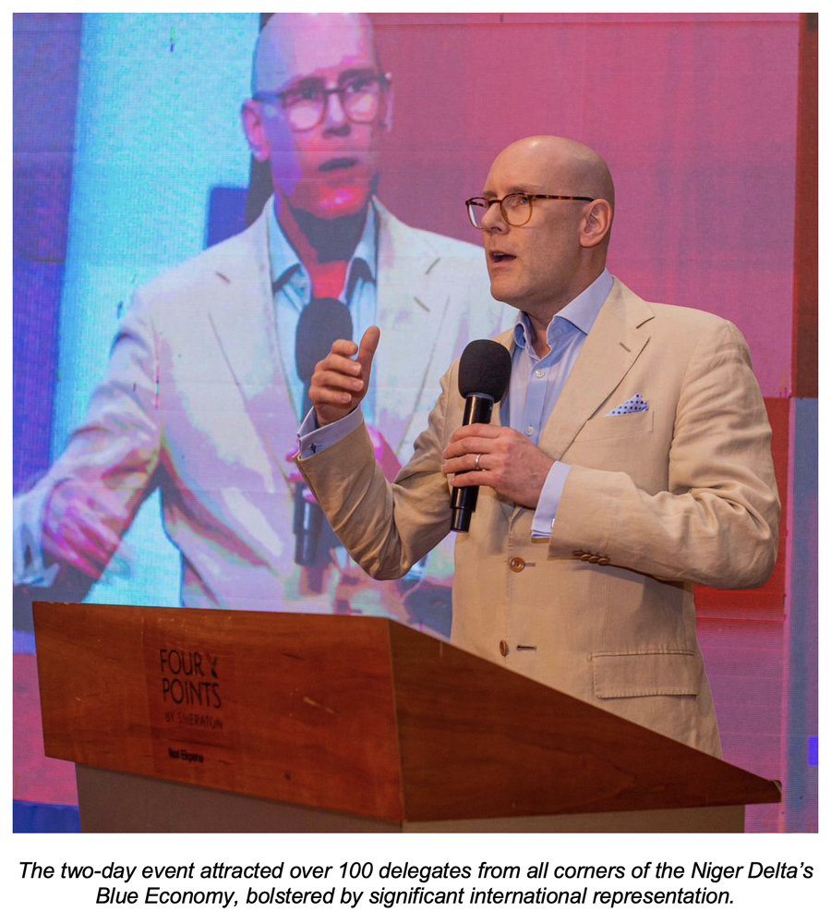
Emerging Themes for the Future Workforce
Reviewing these global examples in the round, a few concerted themes begin to present themselves. There are a host of proven ‘recipes’ for making Blue Economies work, so there is no need to invent or reinvent the wheel.
From Vision to Implementation. The most striking lesson from the Niger Delta Summit and the practice on display is that narrative maturity must be met with a tight focus on delivery. Sadly, the Blue Economy may have more ‘shelfware’ than many sectors; success comes where government frameworks (like Morocco’s ANDA Action Plan or Canada’s strategy) are linked directly to bankable project pipelines and quantified job targets.
Inclusion as a Driver, Not an Add-on. The data is clear: the Blue Economy has a significant gender gap with, for example, women representing only 1.2% of seafarers and 20-22% of the wind energy workforce. However, the practice in Zanzibar (80% women beneficiaries) and Las Palmas (youth vocational focus) shows that inclusion can be an economic driver rather than a cost centre. By similarly targeting the demographics that make up the bulk of Africa’s population, we can ensure that the transition is socially sustainable.
Foundational Maritime Security. This was a dominant theme at the Summit, the consensus being that we cannot discuss blue jobs without addressing underlying maritime security. Between 2017 and 2021, Nigeria recorded 7,143 cases of pipeline breakages and deliberate vandalism, resulting in the theft of 208.639 million barrels of crude oil, valued at $12.74 million. This insecurity acts as a binding constraint on all other blue sectors, from tourism to fisheries. Reducing maritime crime is a prerequisite for the ‘investable environment’ that underpins the creation of jobs.
The Digital and Green ‘Double Transition’. Finally, the Ocean Panel Blue Paper warns that while digitalisation and automation could replace up to two-thirds of traditional maritime positions, they also promise millions of new roles in ship retrofitting, green port operations and blue biotechnology, if underpinned by well-planned programmes of workforce reskilling. The practice at the Technical University of Mombasa that links PhD scholarships to technological advancement is an encouraging model that creates an agile, forward-leaning labour pool.
Bringing it Home to the Niger Delta
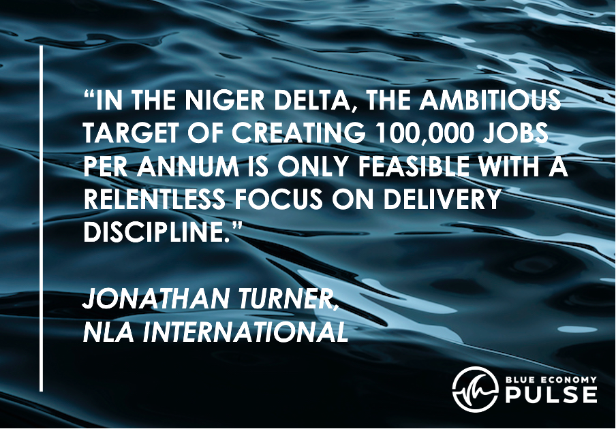
The transition to a sustainable Blue Economy is the great project of our epoch. As the Blue Paper authored by Leila and her colleagues makes clear, the jobs are there for the making. But they will not just appear. They must be engineered through coordinated action between government leadership, private sector investment, and a relentless focus on realistic workforce development. By embracing the realities of new paradigms such as the shift to automation, the right labour pipelines can be built.
In the Niger Delta, the ambitious target of creating 100,000 blue jobs per annum is only feasible with a relentless focus on delivery discipline. We must move beyond the rhetoric of potential and focus on the bankability of assets.
The Niger Delta can become the African flagship for a just transition. The region has the assets and the energy; and we now turn our thoughts to the detail of a hard-working roadmap. Speaking with delegates and organisers after the Summit, I underlined that next year’s event cannot be a repeat of the potentials, rather it must be an update on the implementation, engaging an even wider audience and building the momentum of investment and industrial diversification. I look forward to contributing to such an event, and being inspired again by such a committed set of ambitious Blue Economy leaders in the Niger Delta.

NLA International provides a range of Blue Economy Development services, including Blue Economy Road Mapping and Action Planning. To discuss how we might be able to help you, please contact us at: hello@nlai.blue.
To receive future editions of Blue Economy Pulse, just click 'Follow' on the series' LinkedIn Showcase Page.
We are always open to ideas for Blue Economy Pulse articles. If you would like us to provide insights on a specific area of Blue Economy development, or if you would like to write one yourself, please contact us at: hello@nlai.blue.

